DigiRAMP strategy 2015

DigiRAMP Support the Music.

By streaming revenue directly to creators in real-time



Table of content

Background 4

Numbers 6

Business model 6

Services 6

Third party integration 7

Social integration 7

Content provider segments 7

Professional creators 7

Aspirational artists 7

Bands 8

Indie labels 8

# Background

Most revenue for usage of music comes from:

* Free usage of music as an ad driver.
* Streaming.
* Licensing.
* Public usage
* Sales to consumers

This revenue has to feed an entire food channel.

Here are some of the players:

* Streaming services
* Web shops
* Distribution
* Publishers
* Performance Rights Organizations
* Licensors
* Labels
* Production
* Artists
* Writers
* Composers

The interaction between the parties in the food chain is regulated by laws and a traditional praxis and leaves only a fraction of the income to the creators

Entering the digital age this entire setup in the industry is challenged

* One person and a computer can do entire productions
* The job performed by the publishing companies is down to only taking a cut of the pie
* The amount of music produced is going up
* The payment for usage pr. song is going down
* Streaming is paying next to nothing
* Ads generates the income on social media but is rarely accounted for

While the creative strive to get

* Exposure
* Respect
* Fame
* An income

Money is less important but a part of the recognition and a feeling of not getting ripped off by big companies, despite that most artists has no choice but to share their work on social media for free.

People still pays for music but the revenue rarely reaches the creative because:

* Is held by the channel, only when a threshold is reached the money is paid.
* Artists has to claim their money for usage of their music as an ad driver
* The price one playback on a streaming services is close to nothing
* There is to many parties taking a rake
* There is more music produced than ever so the individual works gets less exposure
* There is no transparency
* Revenue streams are scattered over to many places

Only the licensing marked seems unaffected of the changes but it requires

* A Label
* A publisher
* A lot of legal documents
* Administration
* Access to opportunities

For most creative this is simply not something they know about and if they did the expenses and affords would not be worth the work.

Until now!

Using new technology it's possible to cut the costs for the food chain down to a minimum and let the revenue flow directly to the creators in real-time.

DigiRAMP automatically generates

* A publisher
* A label
* All the legal documents required in the traditional setup
* A complete administration system that automatically streams the revenue directly to the creators bank accounts in real-time

This way

* No rights are violated.
* The costs for the traditional channel are brought down.
* Administration is automated
* There is transparency
* All parties gets paid

# Numbers

2012 - 2014

Streaming

Licensing

Downloads

# Business model

Creating an account on DigiRAMP is free.

There is a fee on all transactions based on the payment gateway plus a DigiRAMP fee

* Stripe takes 30 cent + 2.9% on credit card transactions
* DigiRAMP takes 10 cent + 1.1% on credit card transactions minimum 1 cent
* DigiRAMP takes

There is a limit on free accounts when it comes to storage and transactions

As a part of the building value active users are evaluated as 16 USD each. This will convert on investments and on an exit.

B2B as a Delivery network DigiRAMP can provide cleared music to hardware vendors’ game developers and external streaming services app developer true an API

# Services

DigiRAMP offers a range of services and tools for music creators.

* Promotional tools
* Collaborations tools
* Administration tools
* Sales tools
* Legal framework
* Social interaction

For third party DigiRAMP offers an API with access to all features

* Promotional tools
* Collaborations tools
* Administration tools
* Sales tools
* Legal framework
* Social interaction

# Third party integration

* Garage band
* VST
* RTAS
* AUDIO Units
* Hardware

Easy access to upload/download/stream audio files from third party products

# Social integration

* Facebook.
* Twitter.
* LinkedIn.
* Google+
* Email

A tight integration with social networks lets creators promote their content among fans

# Content provider segments

Described in general

## Professional creators

* Have a lifetime of produced music. Up to 200 songs.
* Many contributors on the productions
* Overall high quality on the music
* Uses real musicians
* Have registered with PRO’s
* Account for x % of the potential user base
* Have some knowledge of the industry

## Aspirational artists

* Have 10 to 20 songs
* Are produced in a project studio
* Have few contributors on the songs
* The quality of the music are mostly low
* Wants to collaborate
* Are seeking recognition more than everything
* Have limited knowledge of the industry

## Bands

* Have 10 to 20 songs
* Are produced in a project studio
* Have few contributors on the songs
* The quality of the music are mostly low
* Wants to collaborate
* Are seeking recognition more than everything
* Have limited knowledge of the industry
* Have fans

## Indie labels

* Have tongs in the thousands organized in catalogs
* Have knowledge of the industry
* Are missing delivery network

# Info graphics

How the players in the industry distribute revenues and how the legal framework connect them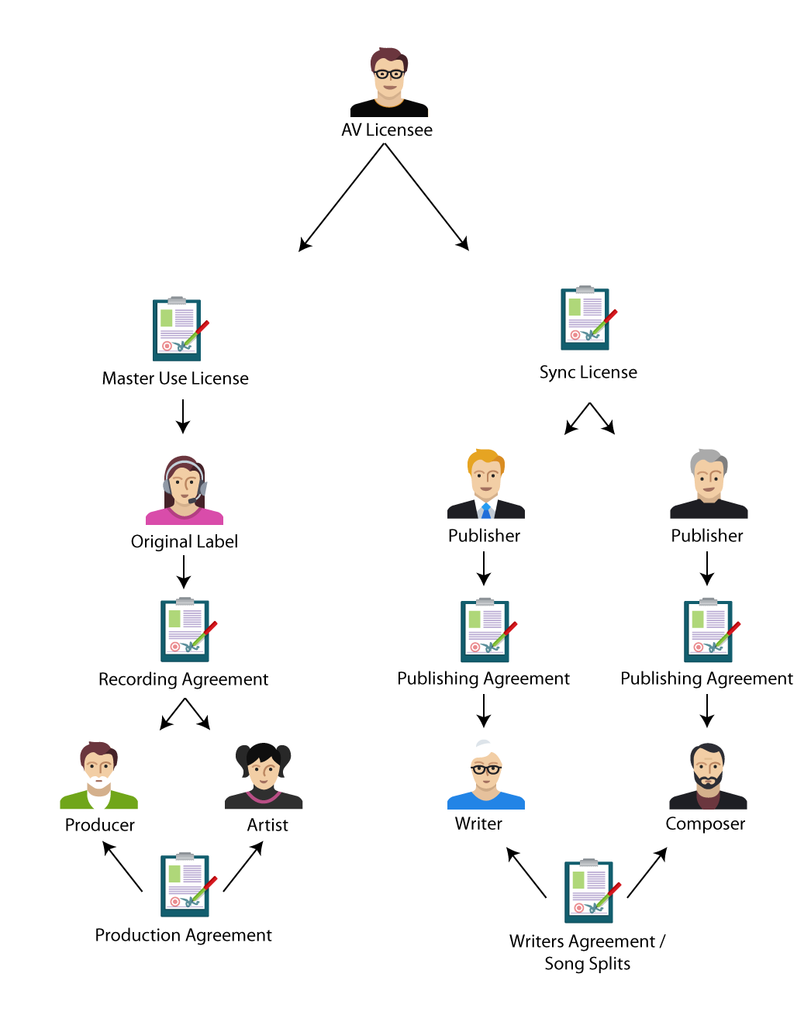

Traditional food chain for licensing

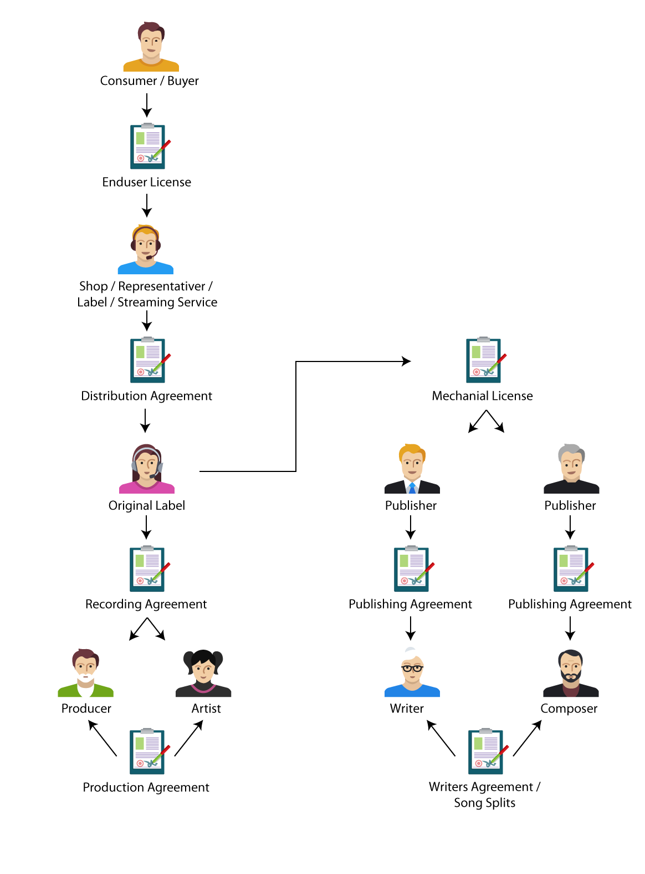

The traditional food chain for ‘record’ sales